

ECLW Hoops Reign3D
Summer Basketball Clinic

What: 2025 Girls & Boys Summer Basketball Clinic
Who: Athletes entering Grades 1 - 6 (2025-2026 school year)
Where: Reign3D - 2798 Darlington Rd, Beaver Falls, PA 15010
When: Sunday, June 22 & Sunday, July 13
Times: Grades 1 & 2 – 9:00 am – 11:00 am
Grades 3 & 4 – 11:15 am – 1:15 pm
Grades 5 & 6 – 1:30 pm – 3:30 pm
*All Time slots will be Co-Ed
Cost: $60
- Please bring WATER only into the gym.
- Please carry basketball shoes into the gym, no outside shoes permitted on the gym floor
- Players ONLY. Parents/spectators NOT permitted. Parents can pick up/drop-off.
Name of Participant: __________________________________ Grade: _____________
Parent/Guardian Name:__________________________ ________________________
Parent/Guardian Phone #: __________________ Email:____________________________

The EC Little Hoops organization is not sponsored by or under the supervision of the Ellwood City Area School District
Sign Ups:
DO NOT RETURN FORMS TO YOUR CHILD’S SCHOOL

- Ellwood City Little Hoopers Basketball Facebook Page to complete registration by completing the online Google Doc
- In person sign ups at National Grind on Saturday, June 7 from 10:00 – 11:00
- Cash/Checks accepted. Make checks payable to “EC Little Wolverine Hoops Inc”

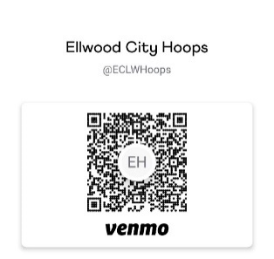
- You can also Scan QR Code for Venmo payment

Authorization/Waiver of Liability
In consideration of the acceptance of this application, I for myself, my child/ward, all executors and assignees, do hereby release and discharge Ellwood City Little Hoopers and/or ECASD and/or its directors, volunteers, and employees, for all claims, demands, or causes of action arising out of participation in both practices and games sponsored by the organization. I attest that I have full knowledge of the risks involved in strenuous athletic activity and that my child/ward is physically able to participate. I hereby authorize the designated volunteer or coaches of Ellwood City Little Hoopers and/or ECASD to act for me according to their best judgment in any emergency requiring medical attention. I further agree to be responsible for any medical or other charges in connection with my child’s/ward’s participation in any event sponsored by the Ellwood City Little Hoopers and/or ECASD. A legal parent/guardian must sign this waiver for the child to participate.
Player Name: _______________________________________________
Parent/Guardian Signature: ____________________________________
Date: ________________

Questions? Please Email:
ECHoopers@gmail.com
The EC Little Hoops organization is not sponsored by or under the supervision of the Ellwood City Area School District.

